**Day 11**

Many children with Down syndrome experience some hearing loss, especially in the early years. Up to 20% may have a sensori-neural loss, caused by developmental defects in the ear and auditory nerves. Many have smaller sinuses and ear canals which result in frequent upper respiratory tract infections: this leads to over 50% suffering from periodic conductive hearing loss due to glue ear.   
Since hearing problems will affect speech and language development, it is particularly important to check children’s hearing carefully and regularly. Also clarity in hearing can fluctuate daily and it is important to check that inconsistencies in response are due to hearing loss rather than lack of understanding or poor attitude.

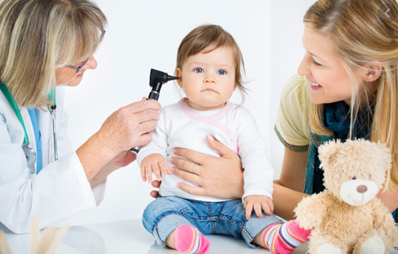

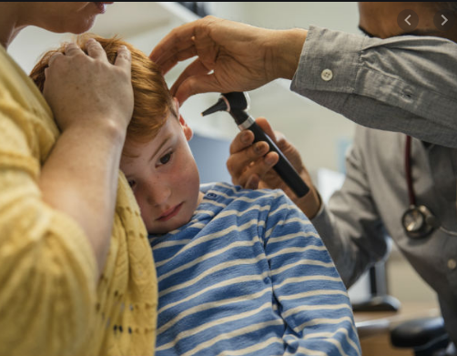

Day 12

People with Down’s syndrome see the world differently – their world lacks fine details and sharp contracts. In order to compensate for the poorer visual acuity we can make the world around them BIG and bold.  
Big and Bold printed materials and images will help – people with Down’s syndrome are visual learners so to help them succeed make sure they can see things. It is very important to take their poorer visual acuity into account in all learning environments.

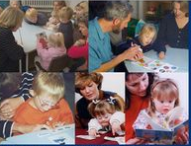

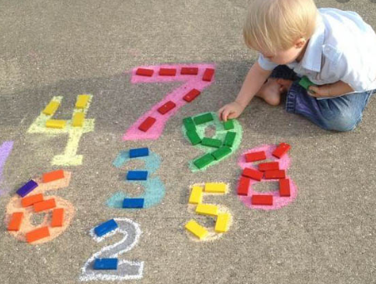

**Day 13**

Many children with Down syndrome have particular difficulties with fine motor skills.  
In addition to hypotonia, the fingers are often short and the thumb set low down. This, together with motor processing and sensory integration difficulties, affects their level of dexterity, manipulation and hand-eye coordination. These in turn affect their ability to hold and control a pen or pencil, use scissors or manipulate small objects.

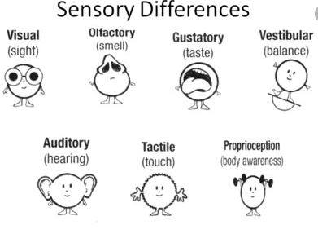

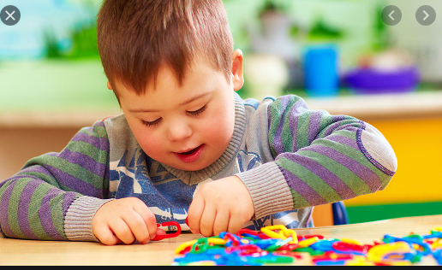

**Day 14**

People with Down syndrome are active participants in educational, social and recreational activities. They are included in the typical education system and take part in sports, music, art programs and any other activities in the community. They are valued members of their families and communities, and make meaningful contributions to society.

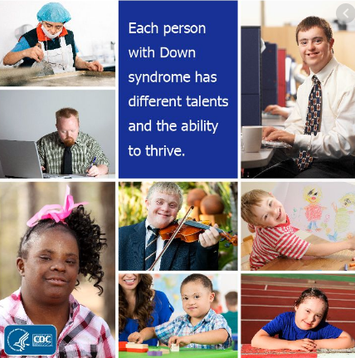

**Day 15**

Though we know that an extra full or partial copy of chromosome 21 causes the characteristics of Down syndrome, researchers are making great strides in identifying how individual genes on chromosome 21 affect a person with Down syndrome. Scientists now feel strongly that it will be possible to improve, correct or prevent many of the problems associated with Down syndrome in the future

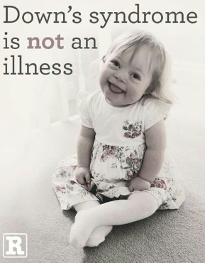

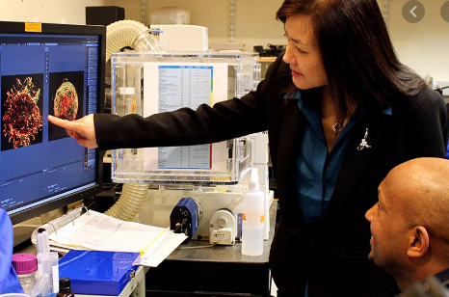

**Day 16**

Students with Down syndrome are included in typical academic classrooms in schools across the country. The current trend in education is for full inclusion in social and educational settings. Sometimes students with Down syndrome are included in specific courses, while in other situations students are fully included in the typical classroom for all subjects. Increasingly, individuals with Down syndrome graduate from high school with diplomas, and participate in postsecondary academic and college programs. They typically do best in an inclusive learning environment, and typical kids do best when they learn about diversity, kindness, and friendship at an early age. Inclusive classrooms teach and benefit all kids.

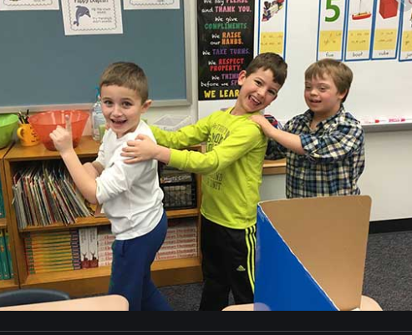

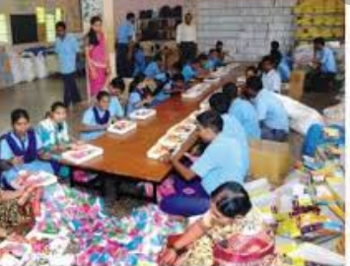

**Day 17**

More and more often, interventions for children with Down syndrome involve assistive devices—any type of material, equipment, tool, or technology that enhances learning or makes tasks easier to complete. Examples include amplification devices for hearing problems, bands that help with movement, special pencils to make writing easier, touchscreen computers, and computers with large-letter keyboards.

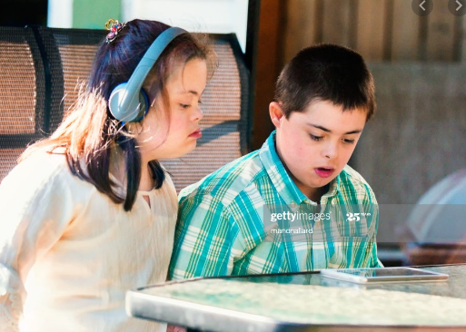

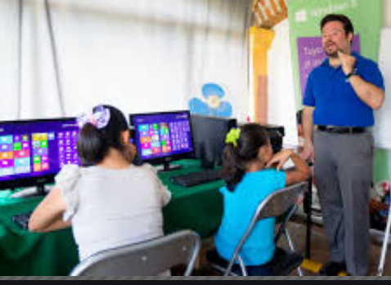

**Day 18**

Computers are excellent tools for learners with Down syndrome as they cater to visual learning but also help strengthen listening skills through auditory prompts. Programs may contain plenty of built-in feedback, encouragement, rewards, and praise, which is delivered when goals are met.

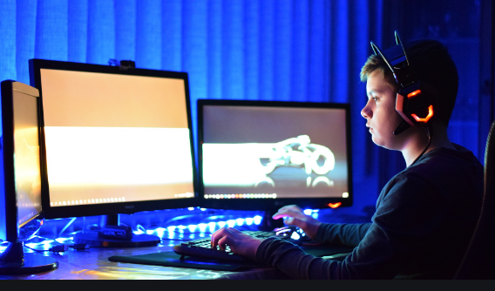



**Day 19**

A variety of therapies can be used in early intervention programs and throughout a person's life to promote the greatest possible development, independence, and productivity. Some of these therapies are physiotherapy,speech –language therapy,occupational therapy and emotional and behavioral therapy.

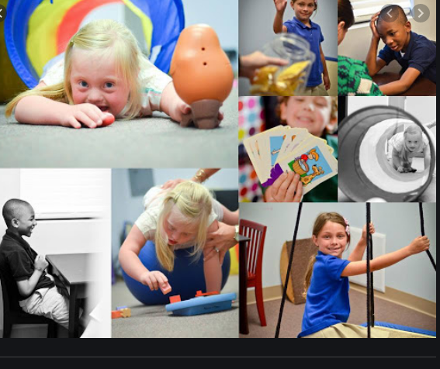

**Day 20**

Physical therapy includes activities and exercises that help build motor skills, increase muscle strength, and improve posture and balance.  
a. Physical therapy is important, especially early in a child's life, because physical abilities lay the foundation for other skills. The ability to turn over, crawl, and reach helps infants learn about the world around them and how to interact with it.  
b. A physical therapist also can help a child with Down syndrome compensate for physical challenges, such as low muscle tone, in ways that avoid long-term problems. For example, a physical therapist might help a child establish an efficient walking pattern, rather than one that might lead to foot pain.



